Above all, you must live as citizens of heaven, conducting yourselves in a manner worthy of the Good News about Christ.
여러분은 그리스도의 기쁜 소식을 믿는 사람답게 생활하십시오. 빌립보서 1:27
Introduction to the series (God wants us to live in joy, in the moment, without anything holding us back)

We learned and believed together through the retreat that there is nothing that is impossible with God. If we have a God so great, then why do we worry?

Clearly, our worries brings us away from God, away from trusting Him. So, let learn together how we will overcome our worries so that we would have unwavering trust in Him.
Share Sang’s story (bring laughter – go slow and be emotional about every worry I had)
-Sang worries: what are my friends going to think?

We worry about life's uncertainties – like being late for work, eating too much, how our boss thinks of us, our aging parents, or our children, how about bad economy? Jobs? Relocation? Terrorists? Your looks? Your safety? – are these causing you to focus away from God? 진로, 결혼, 언제…
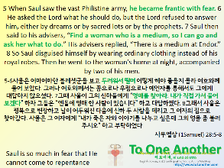 |  | 1. The method of how we will overcome our worries  2. Saul started becoming controlling because of his fears. He could not allow God to be in control.  3. Fear/worries continues to grow and causes us to go deeper into depravity, depression, panic, mental illness.  4. The king of Israel, the king of all God’s people, simply could not repent of his ways, and continued to control the situation to his demise  For you, don’t let fears/worries lead you to control. Let go and trust!
And we grow deeper into fear and worries, and apart from God – this is what it means by our battle is against evil spirits – they attack our mind. They attack our faith and trust in God.

What are some fears we have? -- I can't do it, I'm not good enough, I don't want to be hurt by it, I failed last time, People may think I am stupid – and our minds speak this to us

e.g. when I speak Korean sometimes, I recall people making fun of it; When I feel led to pray for someone, I recall people criticizing me; when living in LI away from family, where to live, finances to buy home, just live this way, what will people say?
Take those thoughts captive. It’s ok when there is a concern in your mind, that you can bring to God, pray, and speak with Him about; but there is a problem when those thoughts keep driving you, holding you, makes you think about it day and night, and not see God’s guidance

Don’t allow your mind to dwell on the worry – focus on God and what He wants you to do
So, our battle is about the mind. It occurs in our lives (not on Sundays), in our workplaces, in our homes, in our times with friends, family, even when we are on the web or on our phones.

Satan attacks us one by one to cause us to fall, cause us to fall into depression and worry, then we will fight each other, get angry, frustrated, and even leave – this is how Satan breaks apart unity.

So then, our fight is to keep the unity, to remain walking with our head, Jesus Christ
To do this, individually, we must fight our minds; then help each other (be accountable)
by not allowing Satan to grab hold of one another. So, enjoy your small group times.
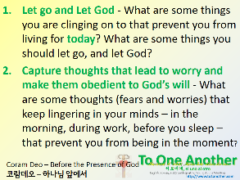 | 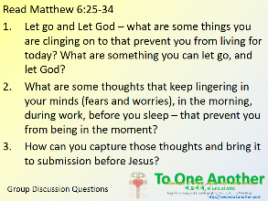Heavy burdens? Do you want to truly live? Joy?

